**WEEK- 1 TASK (OPERATORS)**

**Arithmetic OperatorS**

+ (Addition)

- (Subtraction)

* (Multiplication)

/ (Division)

% (Modulus, returns the remainder of division)

**PROGRAM**

class Main

{

public static void main(String[] args) {

int num1 = 15;

int num2 = 4;

int sum = num1 + num2;

int difference = num1 - num2;

int product = num1 * num2;

int quotient = num1 / num2;

int remainder = num1 % num2;

System.out.println("Addition : " + sum);

System.out.println("Subtraction : " + difference);

System.out.println("Multiplication : " + product);

System.out.println("Division ): " + quotient);

System.out.println("Modulus : " + remainder);

}

}

**OUTPUT:**

Addition : 19

Subtraction : 11

Multiplication : 60

Division : 3

Modulus : 3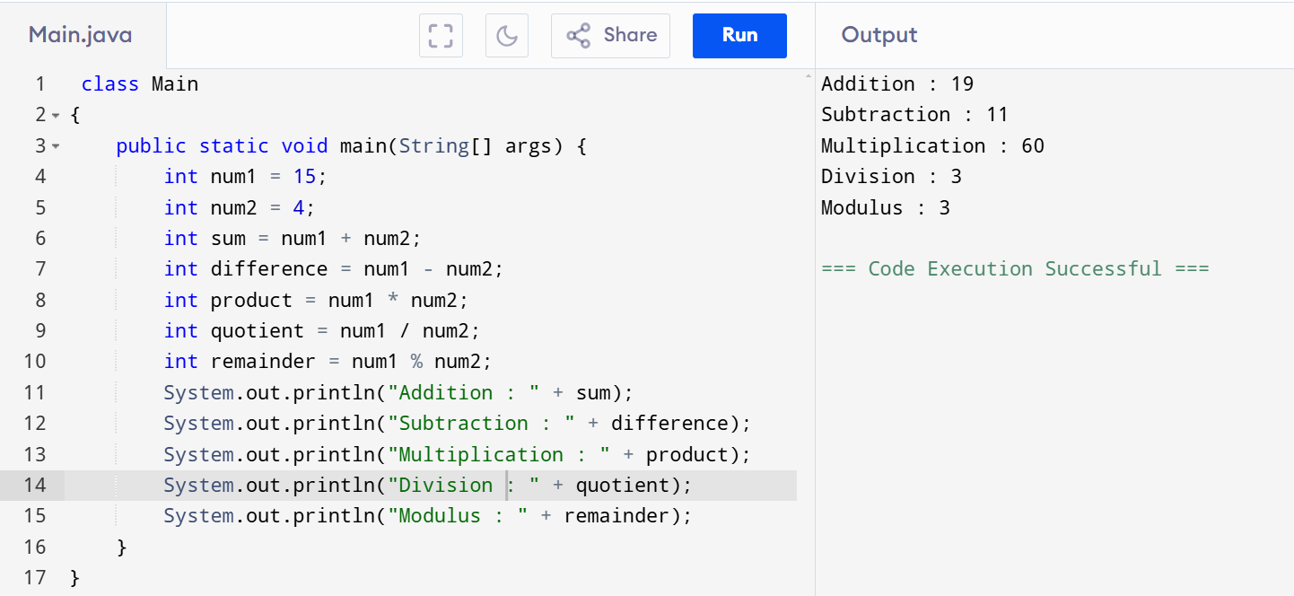

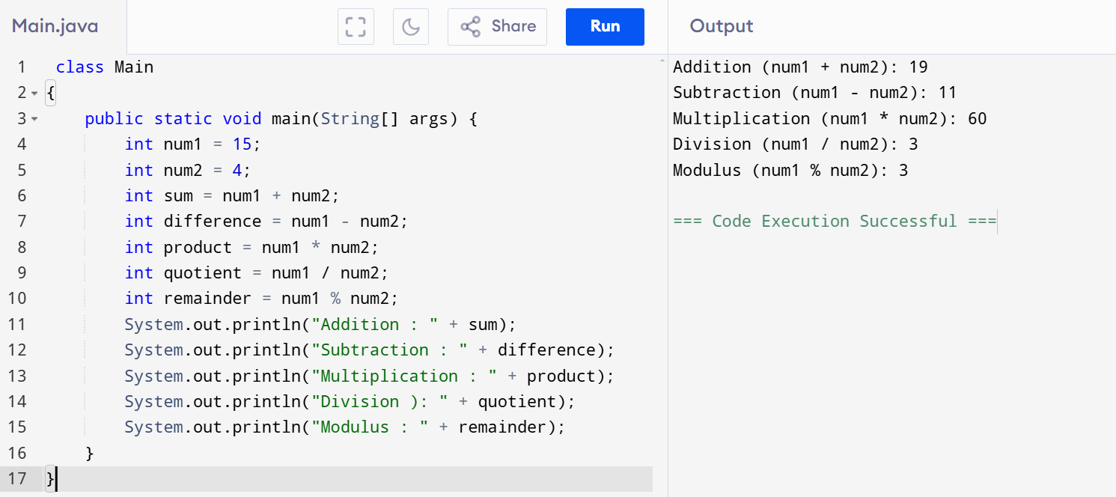

**AND OPERATOR**

class Main{

public static void main(String[] args) {

int age = 60;

boolean isMember = true;

if (age >= 65 && isMember) {

System.out.println("You are eligible for a senior membership discount.");

} else if (age >= 65) {

System.out.println("You are eligible.");

} else {

System.out.println("You are not eligible");

}

}

}

**OUTPUT**

You are not eligible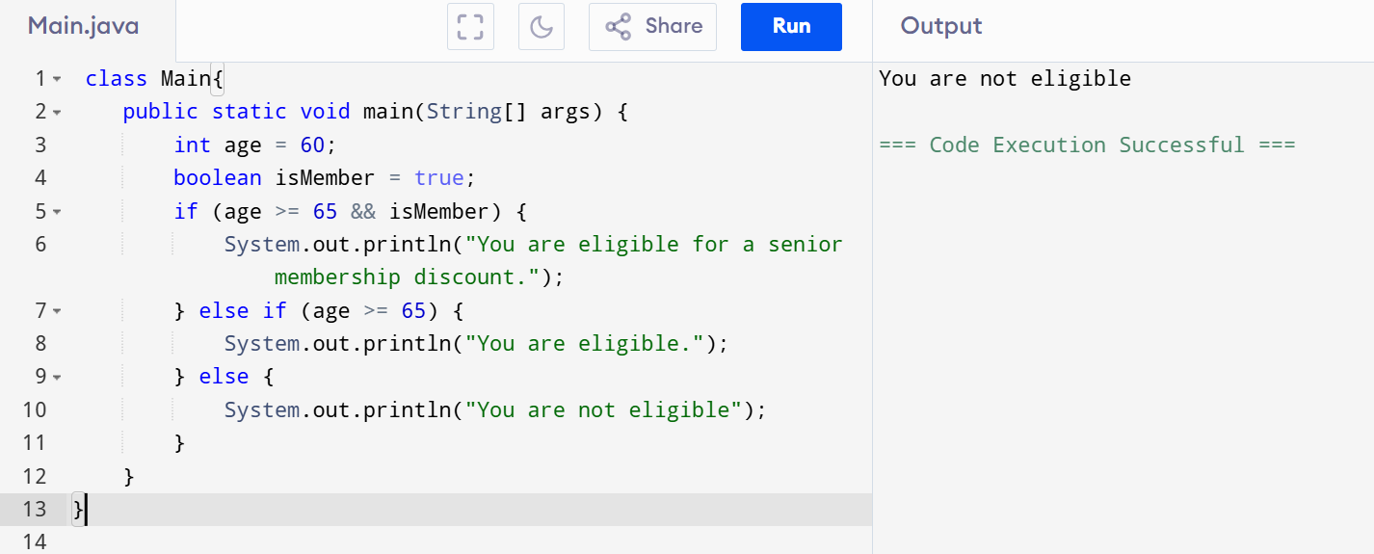

**OR OPERATOR**

class Main

{

public static void main(String[] args) {

int a = 5;

int b = 10;

if (a > 3 || b < 5) {

System.out.println("At least one condition is true.");

} else {

System.out.println("Both conditions are false.");

}

boolean condition1 = true;

boolean condition2 = false;

if (condition1 || condition2) {

System.out.println("One of the conditions is true.");

} else {

System.out.println("Both conditions are false.");

}

}

}

**OUTPUT:**

At least one condition is true.

One of the conditions is true.

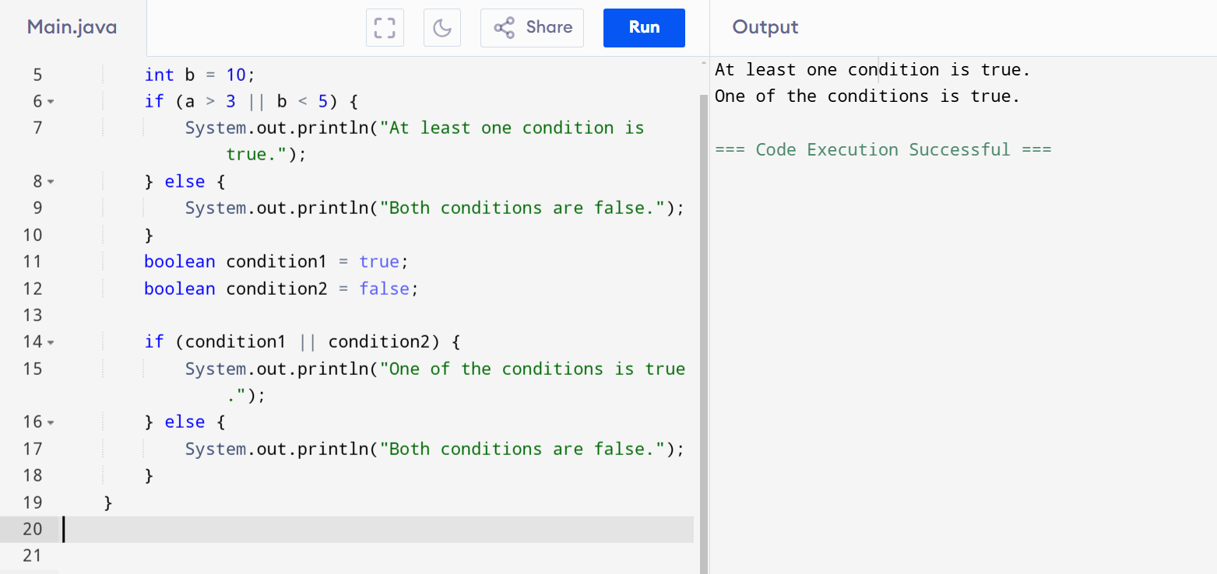

**NOT OPERATOR**

class Main

{

public static void main(String[] args) {

int a = 5;

int b = 10;

if (!(a > 3 || b < 5)) {

System.out.println("Both conditions are false (NOR operation).");

} else {

System.out.println("At least one condition is true.");

}

boolean condition1 = true;

boolean condition2 = false;

if (!(condition1 || condition2)) {

System.out.println("Both conditions are false (NOR operation).");

} else {

System.out.println("At least one condition is true.");

}

}

}

**OUTPUT:**

At least one condition is true.

At least one condition is true.

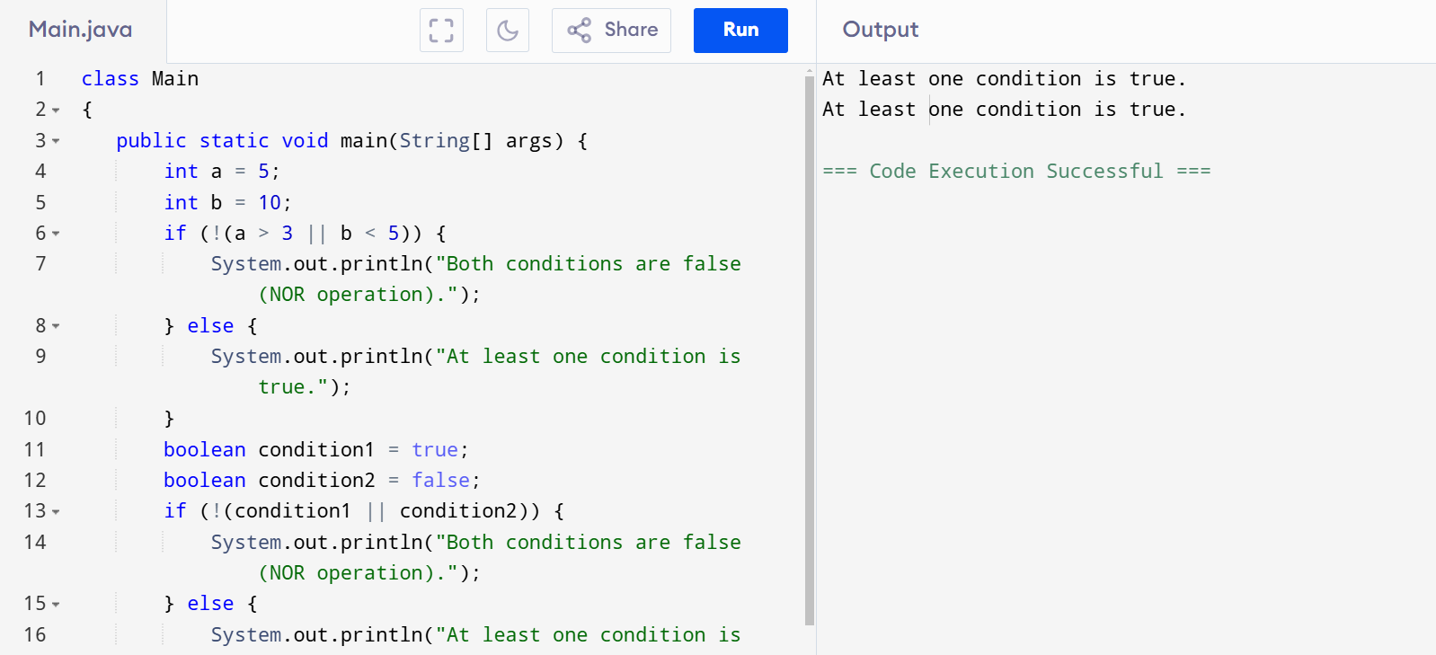

BITWISE OPERATORS

class Main {

public static void main(String[] args) {

int num1 = 12;

int num2 = 10;

int andResult = num1 & num2;

System.out.println("Bitwise AND " + andResult);

int orResult = num1 | num2;

System.out.println("Bitwise OR " + orResult);

int xorResult = num1 ^ num2;

System.out.println("Bitwise XOR " + xorResult);

int complementResult = ~num1;

System.out.println("Bitwise Complement " + complementResult);

int leftShiftResult = num1 << 2;

System.out.println("Left Shift " + leftShiftResult);

int rightShiftResult = num1 >> 2;

System.out.println("Right Shift " + rightShiftResult);

int unsignedRightShiftResult = num1 >>> 2;

System.out.println("Unsigned Right Shift " + unsignedRightShiftResult);

}

}

**OUTPUT:**

Bitwise AND 8

Bitwise OR 14

Bitwise XOR 6

Bitwise Complement -13

Left Shift 48

Right Shift 3

Unsigned Right Shift 3

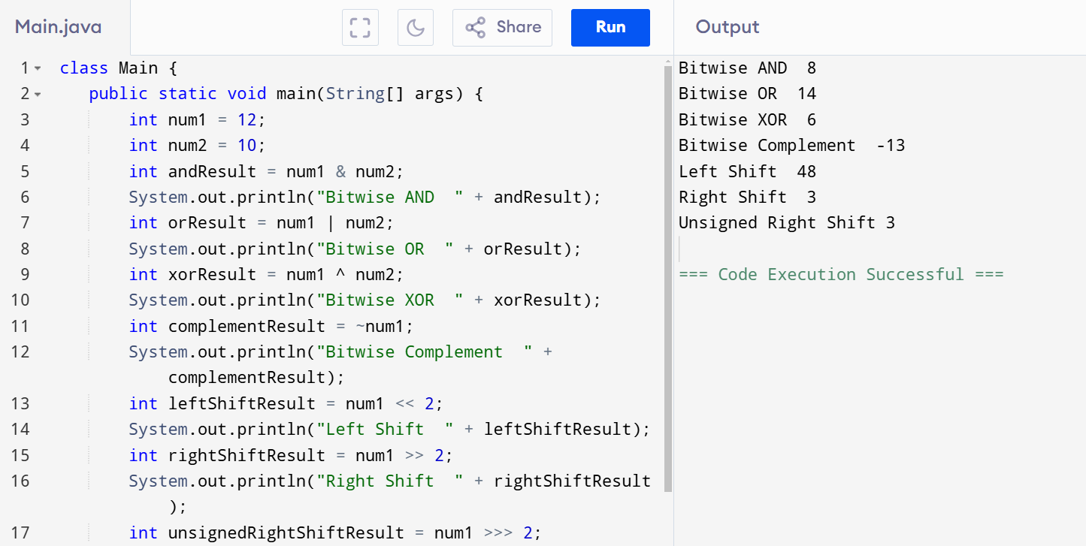

**ASSIGNMENT OPERATORS:**

class Main {

public static void main(String[] args) {

int a = 20;

int b = 4;

int result = a;

System.out.println("Simple Assignment : " + result);

result += b;

System.out.println("Addition Assignment : " + result);

result -= b;

System.out.println("Subtraction Assignment " + result);

result *= b;

System.out.println("Multiplication Assignment : " + result);

result /= b;

System.out.println("Division Assignment " + result);

result %= b;

System.out.println("Modulus Assignment " + result);

}

}

**OUTPUT**

Simple Assignment : 20

Addition Assignment : 24

Subtraction Assignment 20

Multiplication Assignment : 80

Division Assignment 20

Modulus Assignment 0

